Assessment Guide

STAT600: Data Analysis and Interpretation

Semester 2, 2021

Assessment number 1

Assessment Artefact: Written Report (Individual)

Weighting [25%]

Marks [25]

Why this assessment?
Skill Type
Developed critical and analytical thinking | ☐Yes
Developed ability to solve complex problems | ☐Yes
Developed ability to work effectively with others | ☐No
Developed confidence to learn independently | ☐Yes
Developed written communication skills | ☐Yes
Developed spoken communication skills | ☐No
Developed knowledge in the field study | ☐Yes
Developed work-related knowledge and skills | ☐Yes

- Hands on experience in data analysis
- Enhancing employability skills such as excel skills
- Enhancing problem-solving skills

What are the types of employability skills that I will acquire upon completion of this assessment?

Assessment Overview:

This assessment task is based on real-life data. This task requires students to analyse the return distribution of S&P 500 and S&P 500 Environmental & Socially Responsible Index.
Due date: | Friday, 10 September 2021, 5.00pm AEST (Week 7)
Weighting: | 25%
Length and/or format: | The structure is provided below.
Learning outcomes assessed | LO1, LO2, LO4
Graduate attributes assessed | GA4, GA5, GA6, GA8
How to submit: | Report via Turnitin and Excel File via Assignment Inbox
Return of assignment: | Via Turnitin within three weeks
Assessment criteria: | See outcome-focused rubrics in Appendix 1.

Context
As a data analyst, you will have to work on the dataset provided for this assessment task. You need to write a report (answering the questions provided in the structure) applying statistical interpretation.

Instructions
- Submit the report via LEO using Turnitin and an excel file to Assignment Inbox (‘Individual Assignment Excel File’ under Assessment).
- Assignments submitted by other means (e.g., email) or forms (scanned copy, Excel document) will attract no marks.

Data sources:
- S&P Dow Jones Indices LLC, a division of S&P Global:
  - S&P 500 Index (https://www.spglobal.com/spdji/en/indices/equity/sp-500/#overview)
  - S&P 500 Environmental & Socially Responsible Index (https://www.spglobal.com/spdji/en/indices/equity/sp-500-environmental-socially-responsible-index/#overview)
- Excel file containing data for S&P 500 and S&P 500 Environmental & Socially Responsible Index available in STAT600 Project Data file posted under Assessment in LEO.

Analysis period:
1 July 2011−27 July 2021

Structure
Write a report on the return distribution with the following parts:

Question 1 (6 marks)
Evaluate the stock returns of S&P 500 and S&P 500 Environmental & Socially Responsible Index using the descriptive statistics: mean, median, mode and standard deviation and an appropriate graphical presentation of the two return series.
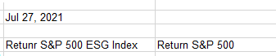

Question 2 (6 marks)

Evaluate whether the returns of the stock returns of S&P 500 and S&P 500 Environmental & Socially Responsible Index are normally distributed. You need to construct histograms to evaluate the return distribution of each return series. Also, you need to use the mean, median, and mode of each return series to evaluate the normality.

Question 3 (13 marks)

- For each return series, generate 20 random samples with a sample size of 50 and 100, respectively, viz. 40 samples for each series, and a total of 80 samples for 2 series. (5 marks)

- Compute the mean for each sample.

- Construct a histogram of the sample means for each series, viz. sampling distribution of the mean.
(b+c = 5 marks)
- Comparing to the histograms in Question 2, which histograms appear to be more normal? What is the underlying theory that explains this phenomenon? (3 marks)

Excel Instructions

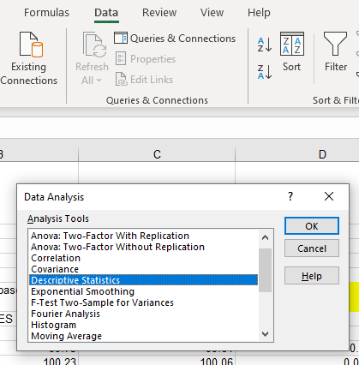

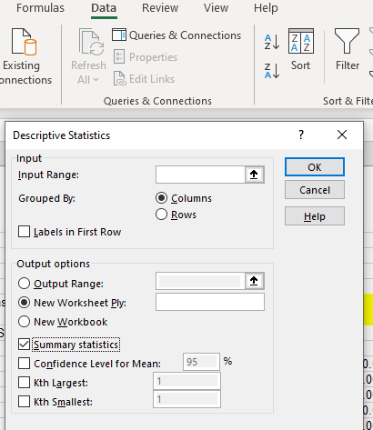

Alternatively, you can use these commands:

=AVERAGE; =MEDIAN; =MODE; = STDEV.S

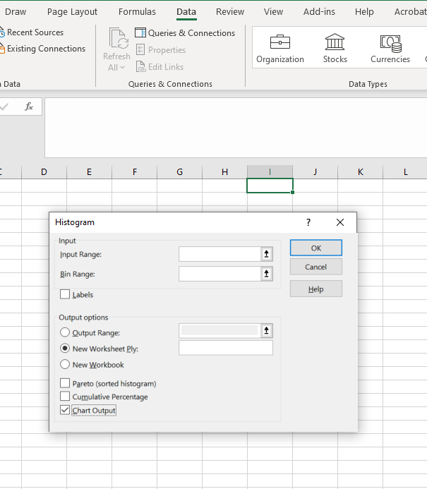
Note: Excel uses a default range for the groups if Bin ranges are not specified. You can specify your own Bin ranges.

Please refer to the Lab Activities # 2 for more instructions and practices on histograms.

Alternatively, Enter insert, then select histogram icon which includes box and whisker in the drop-down menu

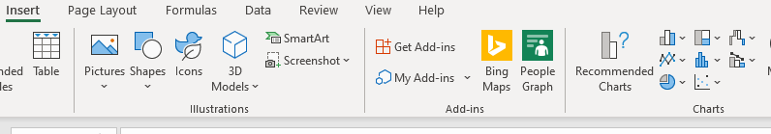

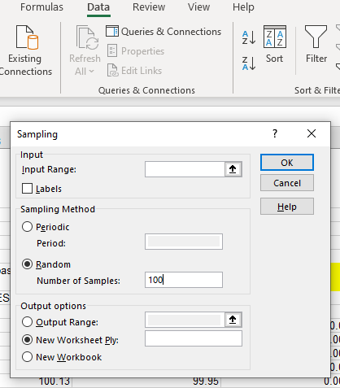

Note: 100 is the sample size.

How do I submit?
Students must submit their reports to Turnitin and Excel files to Assignment Inbox. The software used for checking originality compares works submitted by students with published material from a variety of sources including the Internet. The assignment is to be submitted via LEO/Turnitin and will be checked for originality. A Turnitin similarity score of 10% or greater will be considered cause for concern.

Penalties will be applied for a late submission. Assessment tasks submitted after the due or extended date will incur, for each whole or part of a calendar day that the work is overdue, a 5% penalty of the maximum marks available for that assessment task up to a maximum of 15%. Assessment tasks received more than three calendar days after the due or extended date will not be allocated a mark.

Checklist for students to submit along with their assignment
My submitted assignment report is within the specified word limit | ☐
I have included references using specified referencing style | ☐
I have correctly cited all my sources and references | ☐
I have formatted my report as per the specifications | ☐
I have checked my Turnitin report to ensure the similarity report is acceptable and explainable | ☐
I will be able to supply the process output, if required by my lecturer to prove this my own work (e.g., screen dump of my search and retrieval of journal articles, etc.) | ☐
I have completed proof reading and checked for spelling and grammar | ☐
I have submitted my work before the due date/time | ☐

Some Helpful Websites and Resources
- https://www.spglobal.com/spdji/en/

Who can help me?

Studiosity

Academic skills Unit (ASU)

Campus Lecturer: Dr Philip Cheng (Philip.Cheng@acu.edu.au)

I’m having problems

EX and SC Form to seek extension of submission date for an assessment task.

https://handbook.acu.edu.au/handbooks/handbook_2020/policies_and_general_information/assessment_-_policy_and_procedure/assessment_procedures

Referencing
All referencing should be in ACU Harvard style; however, if you are coming from another faculty, you may choose to use your usual referencing style. If this is the case you must indicate at the top of your reference list what referencing style you are using (e.g. APA, MLA, Chicago, etc).
Please ensure your assignment makes use of in-text citations and a reference list. Missing citations or references is equivalent to plagiarism.

Criteria
The full criteria are compiled in a rubric, which can be found on the following page/s.

Appendix 1: Rubric for [Assessment 1 and 25%]

The marks allocated in the competency rubric are translated into the marks allocated for each assessment question because of the inter-related and integrated contents.
Relevant LO/GAs | Criterion | Does not meet expectations | Meets expectations |  | Exceeds expectations
Relevant LO/GAs | Criterion | Level 1 (NN) | Level 2 (PA) | Level 3 (CR) | Level 4 (DI) | Level 5 (HD)
GA4  LO2  Weight=6 marks  TL=6  Learning stage=D | Generate and apply descriptive statistics | Undeveloped competency in generation and application of descriptive statistics | Basic competency in generation and application of descriptive statistics | Developing competency in generation and application of descriptive statistics | Effective competency in generation and application of descriptive statistics | Advanced competency in generation and application of descriptive statistics
GA8  LO1  Weight=6 marks  TL=6  Learning stage=A | Create histograms and evaluate normality of distribution | Undeveloped competency in creating and interpreting histograms | Basic competency in creating and interpreting histograms | Developing competency in creating and interpreting histograms | Effective competency in creating and interpreting histograms | Advanced competency in creating and interpreting histograms
GA6  LO4  Weight=5 marks  TL=6  Learning stage=D | Generate random samples | Undeveloped competency in generating samples | Basic competency in generating samples | Developing competency in generating samples | Effective competency in generating samples | Advanced competency in generating samples
GA5  LO4  Weight=5 marks  TL=6  Learning stage=D | Generate Sampling distribution of mean | Undeveloped competency in generating sampling distribution | Basic competency in generating sampling distribution | Developing competency in generating sampling distribution | Effective competency in generating sampling distribution | Advanced competency in generating sampling distribution
GA8  LO1  Weight=3 marks  TL=3  Learning stage=A | Apply Central Limit Theorem in the context of the sampling distribution from return series | Undeveloped understanding of Central Limit Theorem in the context of the sampling distribution from return series | Basic understanding of Central Limit Theorem in the context of the sampling distribution from return series | Developing understanding of Central Limit Theorem in the context of the sampling distribution from return series | Effective understanding of Central Limit Theorem in the context of the sampling distribution from return series | Advanced understanding of Central Limit Theorem in the context of the sampling distribution from return series
GA – Graduate Attribute; LO – Unit Learning outcome; TL – Taxonomy Level (or level of complexity) (see Bloom’s Taxonomy); Learning Stage – Introduced (I), Developed (D), Assured (A)

